Social Studies
(Geography)
Chapter 3: Water Resources


Water Resources
Water is one of the most important resources on the Earth. Although 71% of the total surface of the Earth is covered with water, only 1% of freshwater is available for direct human use. Evaporation of water from oceans and precipitation in the form of rainfall-parts of the water cycle-ensure the continuous availability of freshwater. However, water is becoming a scarce resource. India is facing an acute shortage of water supply. India receives about 4% of the global precipitation and ranks 133 in the world in terms of availability of water per person in a year.

Reasons for Scarcity of Water in India
The following reasons can be attributed to the scarcity of water in India:
- A large and growing population has resulted in the scarcity of water resources in the country.
- To provide food resources for such a vast population, water resources are overused to irrigate agricultural fields. Indiscriminate use of wells and tube wells has led to a considerable decline in the water table.
- The establishment of various industries has resulted in the further exploitation of water resources. The discharge of industrial effluents has also degraded the quality of water.
- In India, generation of hydroelectricity on a large scale has also put pressure on the water resources.
- Urban centres have multiplied in the country. Many houses and housing societies have their own independent boring devices. This has further depleted the water table.
- In India, many places or regions may have sufficient water resources but may still suffer from water scarcity. This may be because of the deterioration in the quality of drinking water. Disposal of household and industrial wastes and the use of insecticides and pesticides in agriculture may result in worsening of the quality of water.
Multi-purpose River Projects
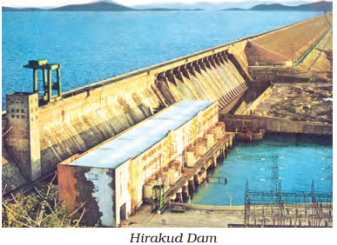
Multi-purpose projects, launched after Independence with their integrated water resources management approach, were thought of as the vehicle that would lead the nation to development and progress, overcoming the handicap of its colonial past. Multi-purpose projects and large dams have been the cause of many new social movements like the Narmada Bachao Andolan and the Tehri Dam Andolan etc. Local people often had to give up their land, livelihood and their meagre access and control over resources for the greater good of the nation.
Dams: A dam is a barrier across flowing water that obstructs, directs or retards the flow, often creating a reservoir, lake or impoundment. “Dam” refers to the reservoir rather than the structure.
Main objectives or Advantages of Multipurpose Project:
- Generation of Power: They produce neat, pollution free and cheapest energy which is the back bone of industry and agriculture. According to the economic survey 2005-06 these produce more than 30,000 M.W. power.
- Flood Control: These projects control the flood because water can be stored in them. These projects have converted many ‘rivers of sorrow’ into river of boon. Example River Kosi.
- Soil Conservation: These conserve the soil because they slow down the speed of water.
- Irrigation: They irrigate the fields during the dry seasons. Many canals have been dug and they irrigate dry areas.
- Afforestation: Trees are systematically planted in and around reservoirs. This helps in preserving “Wild life” and natural ecosystem.
- Water Navigation: They provide for Inland water navigation through main river or canal. It is the cheapest means of transport for heavy goods.
- Fisheries: These provide ideal condition for the breeding of fish. Choosen varieties of fish are allowed to grow.
- Tourist Centres: These projects are well cared and are scientifically developed. So these become the centre of tourist attraction.
Negative Impact of Building Big Dams
At present, many big dams are constructed in our country. These are called multipurpose dams as they help in the generation of electricity and provide water for irrigation and industrial uses. Recently, these multipurpose dams have come under attacks from environmentalists because of the following reasons:
- Damming of rivers and regulating their flow result in excessive sedimentation at the bottom of the reservoir. This may hamper aquatic life and their migration to other water bodies.
- Building of dams result in the submergence of land and vegetation. This results in the decomposition of vegetation.
- Construction of large dams results in the displacement of villagers and communities. The villagers have to give up their lands and their means of livelihood.
- Large forest areas are also submerged because of the building of dams. This threatens our biodiversity.
- As dams provide water for irrigation, intensive irrigation leads to salinity of soil.
- Frequently, the water in large dams is used for the benefit of the urban population and the rural population is often left out. This further widens the gap between the rich and the poor.
- Dams which were initially built to control floods are now causing floods because of sedimentation. In case of excessive rainfall, the release of water from dams often floods the area, causing damage to lives and property.
- Land degradation, water-borne diseases and pollution are some other effects of building large dams.
It has been stressed that it is more beneficial to build small check dams and small reservoirs in order to deal with the problem of water scarcity. It not only provides water for irrigation at the time of need but also recharges groundwater.
Hydraulic Structures in Ancient India
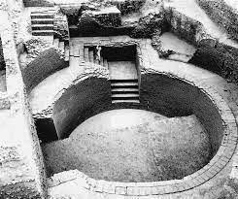
- In the first century B.C., Sringaverapura near Allahabad had sophisticated water harvesting system channeling the flood water of the river Ganga.
- During the time of Chandragupta Maurya, dams, lakes and irrigation systems were extensively built.
- Evidences of sophisticated irrigation works have also been found in Kalinga,(Odisha), Nagarjunakonda (Andhra Pradesh), Bennur (Karnataka), Kolhapur(Maharashtra), etc.
- In the 11th Century, Bhopal Lake, one of the largest artificial lakes of its time was built.
- In the 14th Century, the tank in Hauz Khas, Delhi was constructed by Iltutmish for supplying water to Siri Fort area.

Rainwater Harvesting
Rainwater harvesting is a technique of collecting and storing rainwater for domestic use. It is done in the following ways:
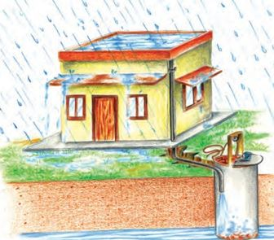
- Rainwater on the rooftop is first collected using a PVC pipe. Water is then filtered by using sand and bricks.
- Water is then taken down either to a sump (a hollow structure or a depression where liquids collect) for immediate use or to a well or any other structure which is dug in the premises of a house.
- Water from this well can be used later for domestic consumption. It also recharges the water table.
India has a long tradition of water harvesting. The technique differed from regions to regions and was also called by different names. Rain roof water harvesting was practised in Rajasthan and in Bengal. Long canals were taken out from large rivers which received water during flooding of the river (inundation canals) in dry regions of western India. Agricultural fields were converted into rain-fed storage structures. This helped the soil to gain moisture. In Rajasthan, many houses had underground storage tanks (known as ‘tanka’). Rainwater from the sloping roofs of the house was collected into these underground tanks through pipes.
Rainwater harvesting is one of the most important methods to deal with the scarcity of water. It not only provides water for domestic use during the summer but also recharges the water table.
Different methods have been adopted in different areas for Rain Water Harvesting.
- In hill and mountainous regions, people have built diversion channels like the ‘guls’ or ‘kuls’ of the Western Himalayas for agriculture.
- “Rooftop rainwater harvesting” is commonly practised to store drinking water, particularly in Rajasthan.
- In the flood plains of Bengal, people developed inundation channels to irrigate their fields.
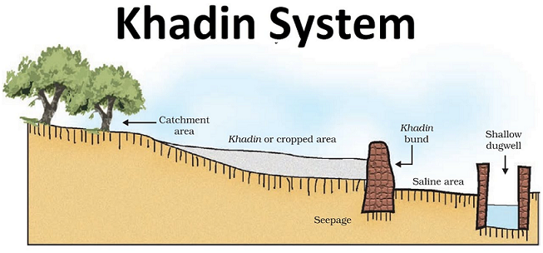
- In arid and semi-arid regions, agricultural fields were converted into rain-fed storage structures that allowed the water to stand and moisten the soil such as ‘khadins’ in Jaisalmer and ‘Johads’ in other parts of Rajasthan.
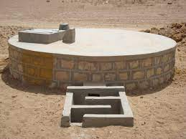
- The tankas are part of the well-developed rooftop rainwater harvesting system and are built inside the main house or the courtyard. This is mainly practised in Rajasthan, particularly in Bikaner, Phalodi and Barmer areas for saving the rainwater. Many houses have constructed underground rooms adjoining the ‘tanka’ to beat the summer heat as it would keep the room cool.
- Tamil Nadu is the first state in India which has made rooftop rainwater harvesting structure compulsory to all the houses across the state. There are legal provisions to punish the defaulters.
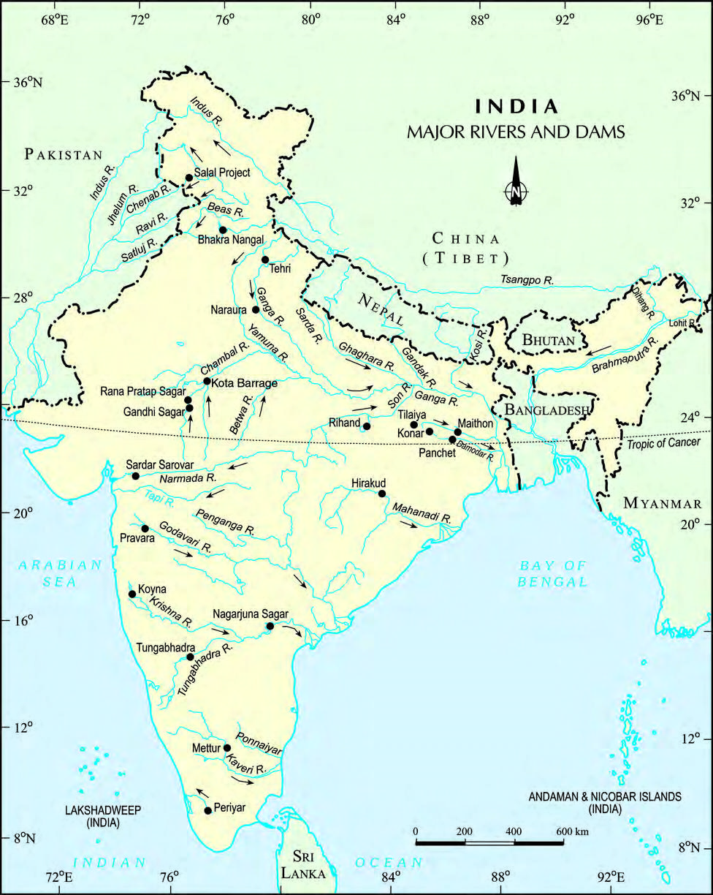
India: Major Rivers and Dams

Important Questions
Multiple Choice questions-
1. Which one of the following is not the cause of water scarcity? [CBSE 2011]
(a) Rapid growth of population
(b) Uneven distribution of water resources
(c) Construction of dams and reserves
(d) Increase in demand
2. Which state has made roof top rainwater harvesting structure compulsory to all the houses across the state? [CBSE 2011]
(a) Kerala
(b) Karnataka
(c) Tamil Nadu
(d) Andhra Pradesh
3. Which one of the following is not the example of Hydraulic structures in Ancient India?
(a) Bhopal Lake
(b) Lake Hauz Kauz
(c) Construction of dams, Lakes
(d) Damodar Valley Project
4. Oceans contain _____________ volume of water.
(a) 90 percent
(b) 75 percent
(c) 96.5 percent
(d) 98 percent
5. Water is a renewable resource because
(a) it is being recycled by human beings.
(b) it is renewed and recharged through hydrological cycle.
(c) it is being renewed through reduction.
(d) it can be reused again.
6. Water scarcity occurs due to
(i) low rainfall in a region
(ii) large population
(iii) over-exploitation
(iv) unequal access
(a) (i) and (ii)
(b) (ii) and (iii)
(c) (i) and (iv)
(d) All of the above
7. In semi-arid regions of Rajasthan the traditional system of storing drinking water in underground tanks are called
(a) Dugwells
(b) Johads
(c) Tankas
(d) None of the above
8. Nagaijuna Sagar Dam is located in the state of
(a) Orissa
(b) Karnataka
(c) Kerala
(d) Andhra Pradesh
9. On which river is the Bhakra Nangal Dam located?
(a) Jhelum
(b) Chambal
(c) Satluj
(d) Chenab
10. The diversion channels of the Western Himalayas are called
(a) Canals
(b) Inundation channels
(c) Kuls
(d) Khadins
11. Which one of the following statements is not an argument in favour of multi-purpose river projects? (Textbook)
(a) Multi-purpose projects bring water to those areas which suffer from water scarcity.
(b) Multi-purpose projects by regulating water flow help to control floods.
(c) Multi-purpose projects lead to large-scale displacements and loss of livelihood.
(d) Multi-purpose projects generate electricity for our industries and our homes.
12. Which is not a source of fresh water?
(a) Glaciers and ice sheets
(b) Groundwater
(c) Surface run off
(d) Oceans
13. According to Falkan Mark, water stress occurs when:
(a) water availability is less than 1000 cubic metre per person per day.
(b) there is no water scarcity.
(c) there is flood.
(d) water availability is more than 1000 cubic metre per person per day.
14. Which of the following are not causes of water scarcity?
(a) Growing population
(b) Growing of water intensive crop
(c) Expansion of irrigation facilities
(d) Individual wells and tubewells in farms
(e) Water harvesting technique
(f) Industries
(g) Roof top harvesting system
15. Bhakra Nangal River Valley Project is made on the river:
(a) Sutlej-Beas
(b) Ravi-Chenab
(c) Ganga
(d) Son
Very Short-
Question 1. What kind of resource is water
Question 2. How much world’s water exists as oceans and fresh water ?
Question 3. Which are the sources of freshwater ?
Question 4. Which is the major source of freshwater in India ?
Question 5. Mention two causes of water scarcity.
Question 6. How much hydroelectric power is produced in India ?
Question 7. State any one reason for conservation of water resources.
Question 8. State any two sources from which freshwater can be obtained under the hydrological cycle.
Question 9. In whose kingdom in ancient India, dams and lakes were built ?
Question 10. What is a dam ?
Short Questions-
(1.) Why water is considered as What renewable resource?
(2.) How to revolutionise the agriculture and why?
(3.) What is the role of urban centers in water scarcity?
(4) What is the main cause of water scarcity?
(5.) Why people are suffering from water scarcity when there is sufficient supply of water?
(6.) What is the advantages and disadvantages of MULTI-PURPOSE RIVER PROJECTS?
(7.) What is dams? What are types of dams?
(8.) What are the effects of Regulating and damming of rivers?
(9.) Why the Sabarmati-basin farmers in Gujrat, were agitated?
(10.) What is the dispute between Karnataka, Andhra Pradesh and Maharashtra?
Long Questions-
1. How have intensive industrialization and urbanization posed a great pressure on existing fresh water resources in India. Explain.
2. Explain any three reasons responsible for water scarcity in India?
OR
Water is available in abundance in India even then scarcity of water is experienced in major parts of the country. Explain it with four examples.
3. What is rainwater harvesting ? How was it used in ancient times ?
Or
How is rainwater harvesting carried out in semi-arid regions of Rajasthan ? Explain. [CBSE 2016-17]
Or
What is rainwater harvesting ? Explain any two different methods of rainwater harvesting in different regions of India.
Or
Why are different water harvesting systems considered a viable alternative both socio-economically and environmentally in a country like India ?
4. Describe the factors that are responsible for the poor condition of India’s rivers – both smaller and big rivers.
Assertion Reason Questions-
- In these questions, a statement of assertion followed by a statement of reason is given. Choose the correct answer out of the following choices.
(a) Both assertion and reason are true and reason is the correct explanation of assertion.
(b)Both assertion and reason are true but reason is not the correct explanation of assertion.
(c) Assertion is true but reason is false.
(d) Assertion is false but reason is true.
Assertion: Ground water is a highly overused resource
Reason: Groundwater is used for domestic and drinking purposes.
- In these questions, a statement of assertion followed by a statement of reason is given. Choose the correct answer out of the following choices.
(a) Both assertion and reason are true and reason is the correct explanation of assertion.
(b) Both assertion and reason are true but reason is not the correct explanation of assertion.
(c) Assertion is true but reason is false.
(d) Assertion is false but reason is true.
Assertion : The availability of water resources varies over space and time.
Reason : Availability of water resources helps in storing water.
Map Question:
- If you intend to visit Hirakund dam marked on the map as A, which one of the following states are you going to?
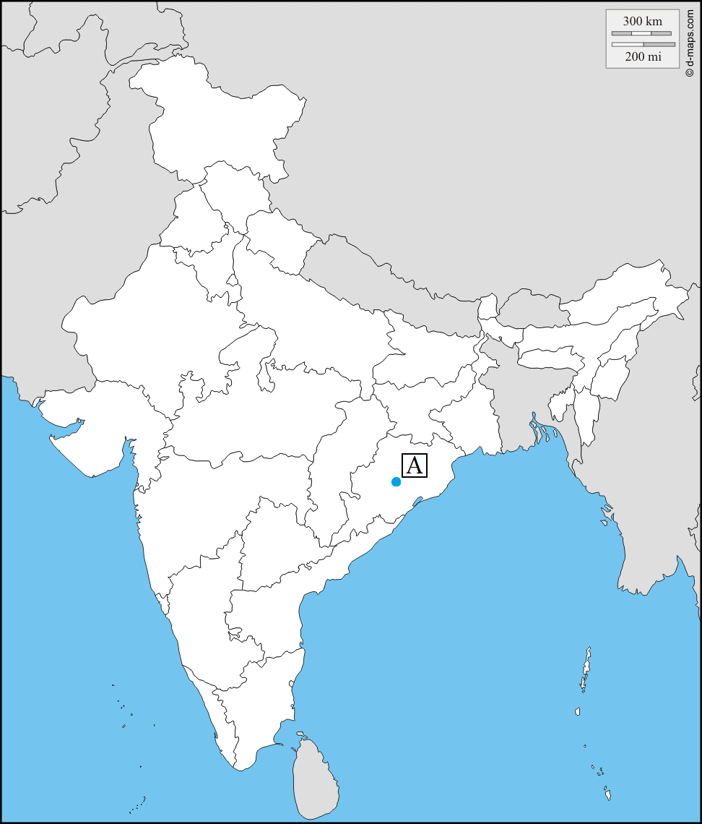
- Tamil Nadu.
- Rajasthan.
- Telangana.
- Odisha.
MCQ Answers-
- Answer: c
- Answer: c
- Answer: d
- Answer: c
- Answer: b
- Answer: d
- Answer: c
- Answer: d
- Answer: c
- Answer: c
- Answer: c
- Answer: d
- Answer: a
- Answer: (e) and (g)
- Answer: a
Very Short Answers-
- Answer: Renewable resource.
- Answer:
- As oceans – 96.5 per cent.
- As freshwater – 2.5 per cent.
- Answer:
- Precipitation
- Surface run off
- Groundwater.
- Answer: Groundwater.
- Answer:
- Rapid growth of population.
- Uneven distribution of water resources.
- Answer: In India hydroelectric power contributes approximately 22 per cent of the total electricity produced.
- Answer: To ensure food security because water is needed for production of crops.
- Answer:
- Precipitation.
- Ground water.
- Answer: During the time of Chandragupta Maurya, dams, lakes and irrigation systems were extensively built.
- Answer: A dam is a barrier across flowing water that obstructs, directs or retards the flow, often creating a reservoir, lake or impoundment.
Short Answers-
- Ans. Freshwater is mainly obtained from surface run off and ground water that is continually being renewed and recharged through the hydrological cycle. All water moves within the hydrological cycle ensuring that water is a renewable resource.
- Ans. Irrigated agriculture is the largest consumer of water. That is why,it is needed to revolutionise the agriculture through developing drought resistant crops and dry farming techniques so that requirement of water will be decreased.
- Ans. The housing societies or colonies in the cities, have their own groundwater pumping devices to meet their water needs and that leads over exploitation of water and decrease the water quality also by domestic and industrial wastes, chemicals etc.
- Ans. The availability of water resources varies over space and time, mainly due to the variations in seasonal and annual precipitation, but water scarcity in most cases is caused by over-exploitation, excessive use and unequal access to water among different social groups.
- Ans. Where water is sufficiently available to meet the needs of the people, but, the area still suffers from water scarcity, this is due to bad quality of water.
- Ans. There are few advantages of multi-purpose river projects such as electricity generation, water supply for irrigation, domestic and industrial uses , flood control ,recreation, inland navigation and fish breeding etc. but in long terms there are lots of disadvantages of these kind projects. These projects causing poor sediment flow ,excessive sedimentation at the bottom of the reservoir, poorer habitats for the rivers aquatic life. It was also observed that the multi-purpose projects induced earthquakes, caused water-borne diseases and pests and pollution resulting from excessive use of water.
- Ans. A dam is a barrier across flowing water that obstructs, directs or retards the flow, often creating a reservoir, lake or impoundment. Dams are classified as timber dams, embankment dams or masonry dams, with several subtypes. According to the height, dams can be categorised as large dams and major dams or alternatively as low dams, medium height dams and high dams.
- Ans. Regulating and damming of rivers affect their natural flow causing poor sediment flow and excessive sedimentation at the bottom of the reservoir, resulting in rockier stream beds and poorer habitats for the rivers aquatic life. Dams also fragment rivers making it difficult for aquatic fauna to migrate, especially for spawning.
- Ans. In Gujarat, the Sabarmati-basin farmers were agitated and almost caused a riot over the higher priority given to water supply in urban areas, particularly during droughts.
- Ans. Krishna-Godavari dispute is due to the objections raised by Karnataka and It is regarding the diversion of more water at Koyna by the Maharashtra government for a multipurpose project. This would reduce downstream flow in their states with adverse consequences for agriculture and industry.
Long Answers-
Answer 1:
• Large scale industrialisation and urbanisation have posed a great pressure on existing fresh water resources as many multinational companies are being set up in India who are the heavy consumers of water for processing, discharge of effluents and as an energy resource.
• Hydroelectricity produced for industrial units have not only posed a great threat to the availability of fresh water resources but also contributed to bad quality of water with large growing number of urban centres and population.
• Modern lifestyle of the urban people has created more demand for water both for domestic purposes and increased consumption of energy.
• In housing colonies to meet the needs of population, water resources are over-exploited resulting in depletion of ground water resources.
• Fresh water needs to be protected from industrial pollution and wastage of water in cities.
Answer 2:
• The availability of water resources varies over space and time, mainly due to the variations in seasonal and annual precipitation.
• Over-exploitation, excessive use and unequal access to water among different social groups.
• Water scarcity may be an outcome of large and growing population and consequent greater demands for water. A large population means more water to produce more food. Hence, to facilitate higher food-grain production, water resources are being over exploited to expand irrigated areas for dry-season agriculture.
• Most farmers have their own wells and tubewells in their farms for irrigation to increase their production. But it may lead to falling groundwater levels, adversely affecting water availability and food security of the people. Thus, inspite of abundant water there is water scarcity.
Answer 3:
(1) Rainwater harvesting is a technique of increasing the recharge of groundwater by capturing and storing rainwater by constructing structures, such as dugwells, percolation pits, checkdams.
(2) Keeping into view the disadvantages and rising resistance against the multi-purpose projects, water harvesting system is considered a viable alternative both socio-economically and environmentally.
(3) Ancient Times :
- In ancient India, along with the sophisticated hydraulic structures, there existed an extraordinary tradition of water-harvesting system.
- People had in-depth knowledge of rainfall regimes and soil types.
- They had developed wide ranging techniques to harvest rainwater, groundwater, river water and flood water in keeping with the local ecological conditions and their water needs.
- In hilly and mountainous regions, people built diversion channels like the ‘guls’ or ‘kuls’ of the western Himalayas for agriculture. Rooftop rainwater harvesting wras commonly practised to store drinking water.
- In the flood plains of Bengal, people developed inundation channels to irrigate their fields.
- In arid and semi-arid regions, agricultural fields were converted into rain fed storage structures that allowed the water to stand and moisten the soil like the ‘Khadins’ in Jaisalmer and ‘Johads’ in other parts of Rajasthan.
- In Bikaner, Phalodi and Barmer, almost all the houses had underground tanks for storing drinking water.
Answer 4: The following factors are responsible for the poor condition of India’s rivers :
(1) Smaller rivers :
- The growing domestic, municipal, industrial and agricultural demand it water from rivers has affected the quality of water. The volume of rivers has been reduced as more and more water is being drained out of them.
- A heavy load of untreated sewage and industrial effluents are emptied into the rivers. This also affects the self-cleansing capacity of the rivers leading to rising pollution of their water. As a result of above factors, the smaller rivers have all turned into toxic streams.
(2) Big rivers : These rivers have been affected by the following factors :
- Population growth
- Agricultural modernisation
- Urbanisation
- Industrialisation : Industries are heavy users of water and also require hydroelectric power to run them.
For example in Delhi, a large amount of domestic and industrial waste falls in the Yamuna river that leads to water pollution. Thus, even the big”rivers like the Ganga and Yamuna are far from being pure and efforts are being made to clean the rivers.
Map Answer:
- (d) Odisha.
Assertion Reason Answer-
1 (a) Both assertion and reason are true and reason is the correct explanation of assertion.
2 (c) Assertion is true but reason is false.

